Minutes DairyCAP Annual: BMPs for feed, manure management, soil and climate scenarios

- Meeting Madison March 1-2, 2016 (Minutes Karin Veltman, edited by Olivier Jolliet)
Action points:

Persons | Action | Date
Al Rotz | Adjust small farm Wisconsin based on comments | asap
Larry | Develop feed rations for 150 cow herd and 1500 cow herd – including protein supplements for each of the foreseen feed ration scenario (for Tier1 and possibly Tier 2 - individual BMPs) | asap
Curtis | Run the updated climate scenarios with wind and solar radiation in APEX to determine impact on crop production | asap
Heather Karsten | Distribute soil data for Lancaster (Pennsylvania) to model group | asap
Richard & Matt  Joyce Cooper | Develop field management schedules for the large and small farm based on the final BMP list and the feed rations developed by Larry  Define soil characteristics for Arlington  Propose an octagon matrix approach to cover the entire space of combined BMPs, with a limited number of model runs | After Larry has developed feed rations  asap, based on proposed BMPs

Selected scenarios and main decisions (see appendices for detailed discussions on each topic)

1. Definition of the small and large farms
- It is decided that two farms will be modelled, a small farm and a large farm. The small farm has 150 cows (lactating and dry cows) plus replacement animals and the large farm has 1500 cows plus replacement animals.

2. Feed ration scenarios
It is decided to consider the following feed BMPs:
- Corn silage/ Alfalfa ratio: Baseline 1:1 versus BMP 3:1
- Forage level: Baseline 65% versus BMP 50%
- Digestibility: Baseline Low NDF versus BMP high NDF
- Feed efficiency (as a surrogate for genetic selection or other effects): baseline low feed efficiency (1.5 kgMilk/kg DMI) versus BMP high efficiency (1.63 or 1.65 kgMilk/kg DMI)
- Fat: baseline Low Fat (3.75%) versus BMP High Fat (5.5%)
- Protein content: baseline high 17% versus BMP low 14%

At tier 1, it is decided that the following three feed scenarios will be run in priority: 1) baseline for all 6 criteria, 2) ‘minimize CH4 scenario’, i.e. BMP for all 6 criteria (red) and 3) ‘minimize CH4 scenario’ BMP with 65% forage level and BMP for the five other criteria.
- The baseline scenario will be an adaptation of the current feed rations for the Twin Birch farm, adapted for 1500 animals and for the baseline defined above.
- The ‘minimize CH4 scenario’ consists of low forage level (50%); high feed efficiency, high NDF, high fat, 14% protein. (The third scenario uses 65% forage instead of 50% forage).
- Larry Chase will parameterize the feed ration scenarios, providing all quantities of feed used for all animals, including the quantities of protein supplements for each scenario.

At tier 2, we may consider individual BMPs separately, according to an octagonal matrix plan that will be proposed by Joyce Cooper.

3. BMP manure management scenarios
BMP – manure management small farm
- The manure management scenarios for the small farm are: 1) 6 months storage, non-separated slurry (baseline); 2) Covered storage (let leak) (BMP1); 3) Enclosed seal structure with flare (BMP2)

BMP – manure management large farm
The final list of manure management scenarios for the large farm is:
- Baseline Lagoon no separation= liquid manure, no processing and 6 month storage basin (lagoon scenario)
- BMP = liquid-solid separation (screw press) and storage basin
- BMP = anaerobic digestion, and storage basin
- BMP = anaerobic digestion, liquid-solid separation and storage basin (New York farm)
- BMP = storage basin covered (lower cost cover – this does not include the cover with methane collection as that will be similar to the digestion scenario) sealed with flare

Compared to the previous list, an anaerobic digestion scenario without liquid-solid separation is added. In this anaerobic digestion scenario there is no solid separation and there is thus no use of manure solids as bedding.

4. Crop & Soil BMPs

The final list of crop & soil BMPs is (for both the small and the large farm):
- Manure application schedule
- Current = 50% in fall and 50% in spring manure (pre-plant) (see Tab " Field management: NY2009")
- 50% Fall & 50% Spring application with cover crop + Corn silage –
- BMP = Spring with 25% of annual manure applied in-season (Developed by Richard, see Tab "Field management: Spring & in-season") with cover crop
- Fall & Spring application with harvested winter crop rye, terminated in the Spring + Corn silage --
- Tillage
- Surface applied, not incorporated (or late incorporation) with tillage after 72 hours
- Surface applied incorporated the same day
- Surface application no-till
- Injection no till
- Soil type
  - It is decided that soil properties specific for each location will be used (rather than using NY soil data for all locations)
  - For NY: the Twin Birch farm soil data will be used, for Wisconsin/Arlington, soil data will be further defined by Richard, for Pennsylvania, Heather Karsten will deliver soil data (representative for Lancaster).

5. Model scenarios and location
- Tier 1 : start to develop and run scenarios for large farm located in NY State (Twin Birch location) and small farm located in Wisconsin (Arlington)
- Tier 2: test the small and large farms in each of the three locations, including the Pennsylvania location (Lancaster, ‘yellow’ region Rob’s climate division map - figure 1).

6. BMP climate scenarios
a) Selected climate scenarios and main decisions
- The observational climate dataset of Rob & Chris will be used as historical-current climate data input for the process-based models.
- At tier 1, for Pennsylvania, the “yellow” region around Lancaster (Figure 1) will be used as location for the Pennsylvania-farm, the "red" region around Madison for Wisconsin and the light brown region around the Twin Birch farm for New York. Other regions can be considered at tier 2.
- At tier 1, we will run in priority 6 climate scenarios (figure 2: 178, 140, 3, 83, 11 and 163) covering high and low changes in temperature and precipitation as well as the lowest, highest, and average yield, respectively. Other scenarios can be considered at tier 2.
- Curtis will re-run all future climate scenarios in APEX and determine the effect on crop production (Scenarios are re-run because we now have data on wind and solar radiation and there have been some changes in the selected climate scenarios by Rob & Chris).
- The modelers will provide future, average annual GHG emission rates over the whole period to the climate model team, for baseline and for BMPs
- The 2 farms (small and large) will be used to estimate emissions for Wisconsin, using a combination of BMPs corresponding to Wisconsin practice
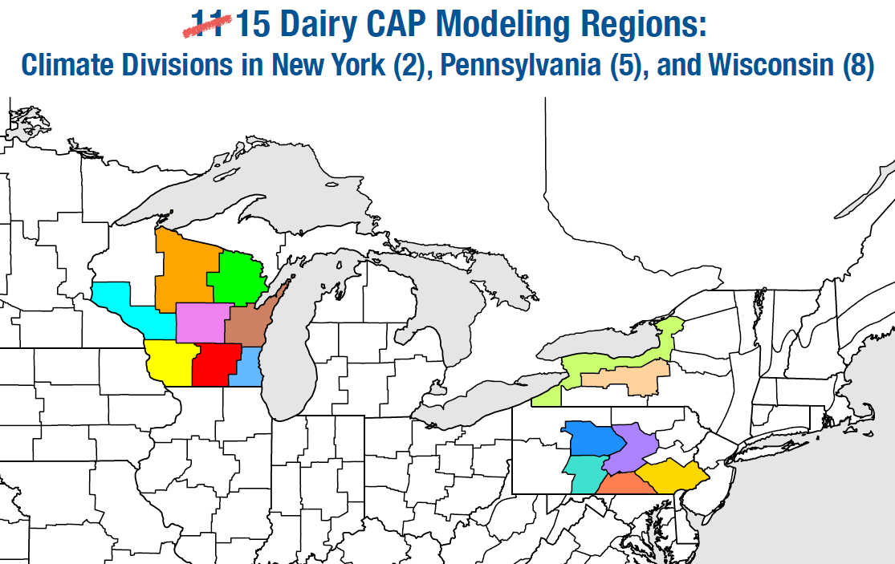
Figure 1. Map of the 15 selected climate scenarios
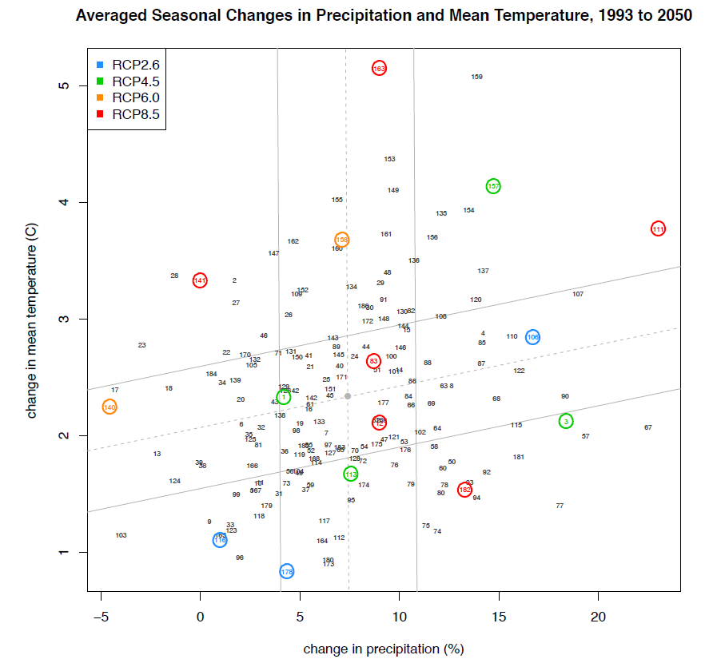
Figure 2. Change in mean temperature and in precipitation for the 15 scenarios. The 6 scenarios foreseen at tier 1 are scenarios 178, 140, 3, 83, 11 and 163.

Appendix: detailed discussions
A1. Detailed discussion on feed ration scenarios
The feed ration scenarios are discussed in terms of several parameters that are thought/known to influence CH4 emissions and/or CH4 emissions per unit milk produced. These parameters include: corn silage : alfalfa ratio, forage level, NDF digestibility, fat content and are based on Mattias and Larry’s feed scenario lists.

Larry ran 16 feed scenarios in CNCPS to identify approx. 5 scenarios that would of interest to run by the other modelers (in the BMP scenario analysis study). The feed scenarios are based on the list of Mattias plus some extra scenarios. In the scenarios, Larry tried to keep the milk production constant.
The list of Larry consists of several scenarios with different corn silage: alfalfa ratios. Larry: More corn silage, emissions go down (both CH4 and NH3). Matias mentions that in his feed experiments, he sees a nonlinear (quadratic) effect of corn silage:alfalfa ratios on CH4 emissions. The effect on N emissions is more consistent.
Dairy herds are currently on 2/3 corn silage and 1/3 alfalfa at the Twin Birch farm.
Greg asked which 2 feed scenarios should be modeled.
Larry: 50% corn silage and 75% corn silage (that is, 1:1 corn silage: alfalfa and 3:1 corn silage:alfalfa).

Forage level influences CH4 emissions: low forage level generally results in lower CH4 emissions. Two scenarios are suggested: 50% forage and 65% forage.
Larry mentions that NDF is important in the low forage ration: you won’t get to 65% forage with low NDF.

NDF digestibility influences feed conversion efficiency. Low NDF generally results in a low feed efficiency, and a high NDF results in a high feed efficiency. High feed efficiency results in a lower emission of CH4 per unit milk produced as milk production increases. Two scenarios suggested: low NDF and high NDF.

Two scenarios are suggested for fat%: 1) 3.5 -4.5% fat (baseline) and 2) 5.5%.
Matias says that 5-5.5% fat is maximum. This fat% can be obtained from distiller’s grain (?).

Doug Young say that percentage protein in rations is also important and that we need a range for that. 14% - 17% protein is feasible range.

In the end, it is decided that 3 scenarios will be run: baseline (current Twin Birch farm ration), ‘minimize CH4 scenario’, and ‘minimize CH4 scenario’ with 65% forage level.
‘Minimize CH4 scenario’: low forage level (50%); high feed efficiency, high NDF, high fat, 14% protein.
A second ‘minimize CH4 scenario’ is added, as Doug Young mentions that 50% forage is not likely to be adopted by farmers, 65% forage level would be more reasonable.

A2. Detailed discussion on the farm manure management and farm size
BMP – detailed discussion of the manure management scenarios for the small farm
- The manure management scenarios for the small farm are: 1) 6 months storage, non-separated slurry (baseline); 2) Covered storage (let leak) (BMP1); 3) Enclosed seal structure with flare (BMP2)
The baseline practice (manure management) is changed to ‘6 months storage’. For 150 cows, ‘no storage basin’ is unlikely. For 50 cows, ‘no storage’ may exist (Heather and Al). Changing the baseline practice to 6 months storage makes the large and small farm more similar. There are 2 conflicting issues: a 50 cow farm size is unlikely in the future, but would give a more different manure system than the large farm.
Al mentions that maybe we should model 3 farms: small (50 cow), mid (+/- 200 cow) and large (1000 cow) – if diversity is important. We cannot scale down from 150 cows to a very small 50 cow farm.
Tom Richard asks if we are trying to represent all farms in these states? And improve EPA inventory? Or do we try to help/inform farmers how they can change to adapt to climate change? In the latter case, the small, 50 cow farms are likely not changing as they are too small to adapt. For the virtual farm project, two farms small (150 cow) and large (1500) are relevant and should be modelled separately – even if manure management systems are similar – so that farmers can find their farm on the virtual farm website.
It is decided that two farms will be modelled: a small farm of 150 cows and a large farm of 1500 cows.
The manure management scenarios for the small farm are:
- 6 months storage, non-separated slurry (baseline)
- Covered storage (let leak) (BMP)
- Enclosed seal structure with flare

BMP – detailed discussion of the manure management for the large farm
The final list of manure management scenarios for the large farm is:
- Baseline Lagoon no separation= liquid manure, no processing and 6 month storage basin (lagoon scenario)
- BMP = liquid-solid separation (screw press) and storage basin
- BMP = anaerobic digestion, and storage basin
- BMP = anaerobic digestion, liquid-solid separation and storage basin (New York farm)
- BMP = storage basin covered (lower cost cover – this does not include the cover with methane collection as that will be similar to the digestion scenario) sealed with flare

Compared to the previous list, an anaerobic digestion scenario without liquid-solid separation is added. In this anaerobic digestion scenario there is no solid separation and there is thus no use of manure solids as bedding.

A3. Detailed discussion on crop & soil BMPs:
The BMP list is updated to account for ‘double cropping’. Matt: should evaluate double cropping both as cover crop (not harvested) and winter crop (harvested). Rye can be used as winter crop.
Tillage. Heather: a common practice in Pennsylvania is surface applied, no-till. Al mentions that from a GHG perspective no incorporation and no till are very similar. However, they are not similar from a water quality perspective. Hence the need to include both. Bill mentions that DNDC cannot incorporate within 2 hrs. The model can incorporate the same day. Incorporation within 2 hrs. is changed to incorporation the same day.
Richard will develop field management scenarios for the different BMPs with help of Matt Ruark.
The updated BMP lists are presented to the whole group by Olivier. For the large farm, the following BMPs are accepted: feed rations, manure processing & storage, crop& soil – manure and tillage.
Soil properties
- It is decided that soil properties specific for each location will be used (rather than using NY soil data for all locations)
- For NY: the Twin Birch farm soil data will be used, for Wisconsin, soil data from Al will be used, for Pennsylvania, Heather Karsten will deliver soil data (representative for Lancaster)
The discussion continues with the soil data to be used. Question is if the NY soil data can be used for Wisconsin? Matt thinks that the NY farm soil is probably representative for Wisconsin. Al mentions that clay content is an important driver for GHG, clay content may not be similar. Bill mentions that it would be fairly easy to change soil parameters in the model ones the scenarios are set up. According Greg, we would take soil properties representative for each location. It is decided that soil properties specific for each location will be used (rather than using NY soil data for all locations). For NY: the Twin Birch farm soil data will be used, for Wisconsin, soil data from Al will be used, for Pennsylvania, Heather Karsten will deliver soil data (representative for Lancaster – is in ‘yellow’ region in Rob’s climate division map).
Crop rotation
Richard wants to know what kind of crop rotation are we running? We can pick a couple of crop rotations, get the yield per ha, and depending on the feed rations we can select the areas and rotation schedule. We need to know what the feed rations require in terms of crop rotation. Olivier mentions that we try to produce everything on the farm and adapt the area if needed. We can fix a certain number of rotations, maybe also in terms of fertilizer applied and match that with the yield required for feed.
BMP list – small farm
- The feed scenarios for the small farm will be run for the large farm as well
- Larry will develop detailed feed rations, including protein supplements
Model scenarios – Tier 1 and 2
- Tier 1: develop and run scenarios for large farm located in NY State (Twin Birch location) and small farm located in Wisconsin (Arlington)
- Tier 2: test the two farms in each of the three locations, including the Pennsylvania location (Lancaster, ‘yellow’ region Rob’s climate division map - figure 1).

A4. Detailed discussion on climate scenarios
Rob and Chris have prepared climate dataset in three main regions in New York, Pennsylvania and Wisconsin. Each of these regions is further divided into sub-areas: there are 2 subareas for NY, 5 for Pennsylvania and 8 for Wisconsin (Figure 1). The climate datasets are bias-corrected (by comparing model predictions with historical climate data) and are developed in such a way that they represent climate data from a weather station (single point data).
Historical-current climate dataset
Al wonders what we should use for the baseline scenario (current climate), real historical data or the climate dataset from Rob & Chris? Al expects that the differences in IFSM predictions based on real historical data and IFSM predictions based on the climate dataset from Rob & Chris are probably small over 25yrs. Bill expects to see a difference for N2O on a day by day basis and asks if we work with daily data or averages over 25 yrs.? Olivier: we will use 25 yr. (or 10 yr.) average, as in previous model comparison study. Chris mentions that the decision of a specific dataset also depends on how this data is presented to the public: with projected data, a problem can be that the public questions data when they ‘miss’ a specific event. Olivier prefers to use 1 dataset (for historical-current climate and future climate projections) if possible. Rob mentions that they also have observational data as this was used for the bias correction. It is decided that the observational data of Rob and Chris will be used for the historical-current climate.
Pennsylvania sub-area
Olivier wants to know which sub-area (of Rob’s climate division map) we should choose as a location for the Pennsylvania-farm. It would be interesting to choose a region which is close to NY City, as proximity to a large city would make a difference in the human health impacts (large exposed population). Which Pennsylvania dataset would have NY City downwind? Chris advises to use the ‘yellow’ subarea around Lancaster and not the ‘purple’ or ‘blue’ subareas as the latter do have NY City downwind, but there is a mountain ridge in between which may affect concentrations.
Scatterplot temp. vs. precipitation
Future crop production (in DM yield kg/ha) was predicted with APEX for all climate scenarios. The data present the average yield (over 30 yrs.). To model the climate scenarios, Curtis has adopted the planting dates, if necessary.
Olivier compared the APEX predictions of yield with the scatterplot of Rob and Chris, and identified which 6 climate scenarios correspond with the lowest, highest, and average yield, respectively. The idea is that people can run these 6 scenarios (178, 140, 3, 83, 11 and 163).
in priority at tier 1 if there is insufficient time to run all scenarios (tier 2). It is noticed that some scenarios have changed. Rob mentions that he has removed one scenario because the climate model could not predict all required parameters). Curtis will re-run all climate scenarios in APEX to determine the impact of the different scenarios on crop yield. A new run is also needed because we now have solar radiation.

Model output for climate modelers
Chris and Rob will use the output of process-based models in their project. (In their project they wish to determine the impact of a reduction in future GHG emissions in the dairy agricultural system on the climate (global). For this, they need future GHG emission rates. There is a short discussion on whether predicted emission rates at two points in time, 2015 and 2050, is sufficient to derive a meaningful average emission rate per year. As the models can provide annual average emission rates, it is decided that the modelers will provide future annual GHG emission rates over the whole period to the climate model team.
Wisconsin region
Olivier: For the future emission scenario, we need to know if we can model the whole region of Wisconsin with 2 farms. Al mentions another project that he is involved in that models a region, Beef project. In this project, they simulate 20 different operations, which are averaged to obtain an estimate of the region. Bill mentions that if we model different manure management systems, we can have an idea of regional emissions if we know the percentage of farms that have this specific manure management system. Tom Richard ask if 75% of the milk production is associated with small farms and large farms? Matt R.: yes. It is decided that the two farms will be used to estimate regional emissions for Wisconsin.

